# **Lab 01: Design Tools**

## State Diagram

*Draw a state diagram to describe an FSM for a single traffic light on a timer.*

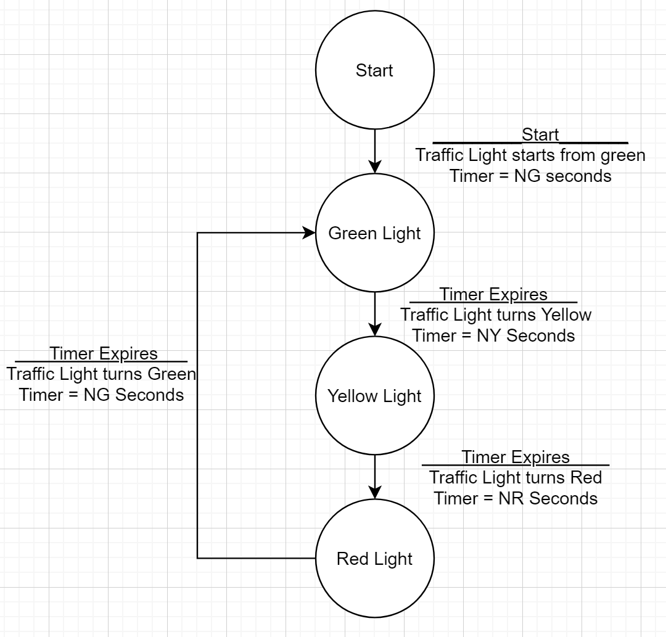

## Structure English

*Use Structured English to describe a binary search looking for a name in a contact list. Ensure any words that would be defined in a DD are underlined.*

CREATE a string called Name in array form

READ from input to the string Name

SET Beg is index of beginning of Contact List

SET End is index of end of Contact List

DO WHILE Beg < End

Mid = (Beg + End)/2

IF Name>=Mid *Compare characters starting from first one*

Beg = Mid

ELSE

End = Mid

ENDIF

ENDDO

OUTPUT Name

## Data Dictionary

*Create DD to describe a student at Dalhousie. The DD should include things like program, name, age, sex, etc*.

Student Info = Name + Age + Gender + Program + Student ID + Campus

Name = First Name + (Middle Name) + Last Name *String of alphabetic characters*

Age = *Numeric number*

Gender = [Male | Female]

Program = [Undergraduate | Graduate | Professional]

Student ID = B00+ *6 unique number*

Campus = [Main Campus | Engineering Campus | Truro Campus]

## Decision Table

*Write a decision table to verify if an X-Makina assembler label is valid or not. The definition of a label can be found in the X-Makina assembler user guide on Brightspace.*

|  |  |  |
| --- | --- | --- |
| Conditions |  |  |
| String less than 32 characters | Y | - |
| In Instruction table | N | - |
| In Symbol table | - | N |
| Begin with and alphabetic character | Y | - |
| Alphanumeric | Y | - |
| Actions |  |  |
| XM3 label is valid | X |  |
| XM3 label is not valid |  | X |